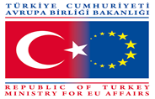
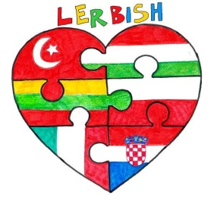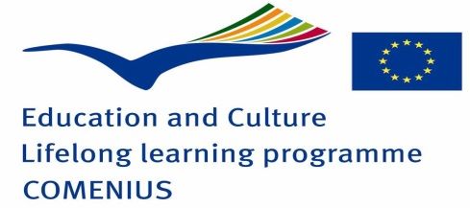
QUESTIONNAIRE ABOUT TURKEY
1-What is the capital city of Turkey?

2-Circle the Turkish flag below.
- 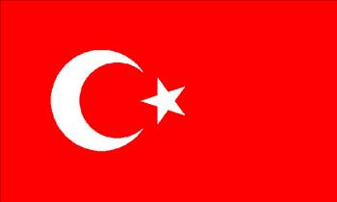 b) 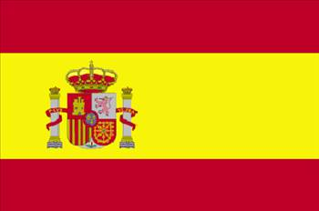 c) 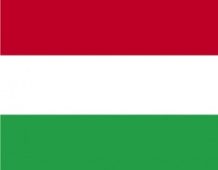

d) 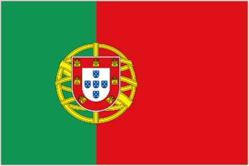 e) 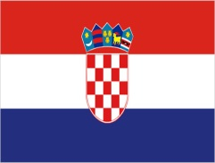 f) 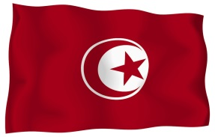

3-Which one is the traditional costume of Turkey?
- 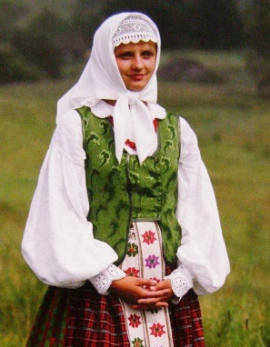 b) 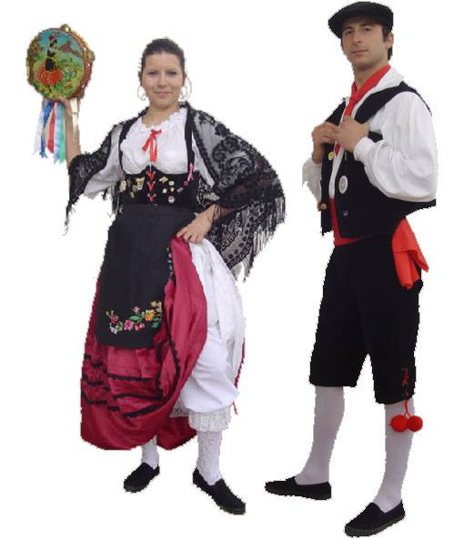 c ) 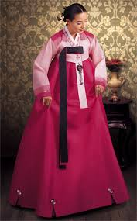
d) 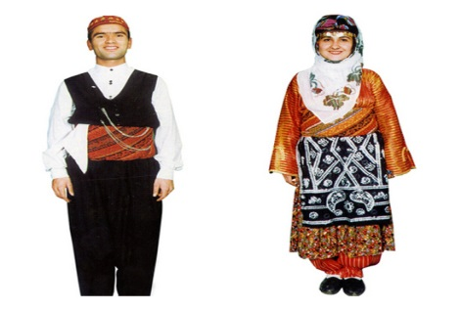 e) 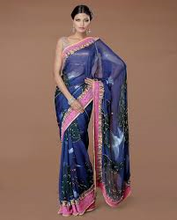

4-Which one is the Turkish dish?
- 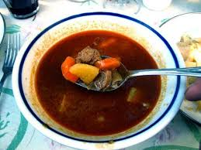 Goula
GOULASH
- 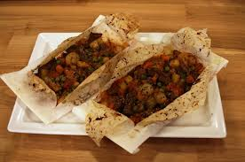
KAĞIT KEBAB

- 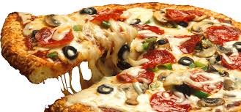
PIZZA
5-Please write 3 popular places you remember in Turkey.

6-In which city are you doing this Comenius Project with in Turkey?

7-What is the city of Malatya famous for?

8-Which one is the name of Turkish school?
a)Ataturk Secondary School
b)Mehmet Topsakal Secondary School
c)Haniminciftligi Meliksah Vocational Religious Secondary School
d)Ziya Gokalp Primary School
e)Ogretmenler Religious Secondary School

9-What does ‘’ MERHABA’’ mean in Turkish?
a)good morning c)goodbye e) see you
b)hello d)thank you

10-Match the numbers with their meanings.
- 1 1)İki
- 2 2)Dört
- 3 3)Beş
- 4 4) Bir
- 5 5) Üç

GOOD LUCK!
Seher Türkhan Eren
English Tecaher/ Coordinator

